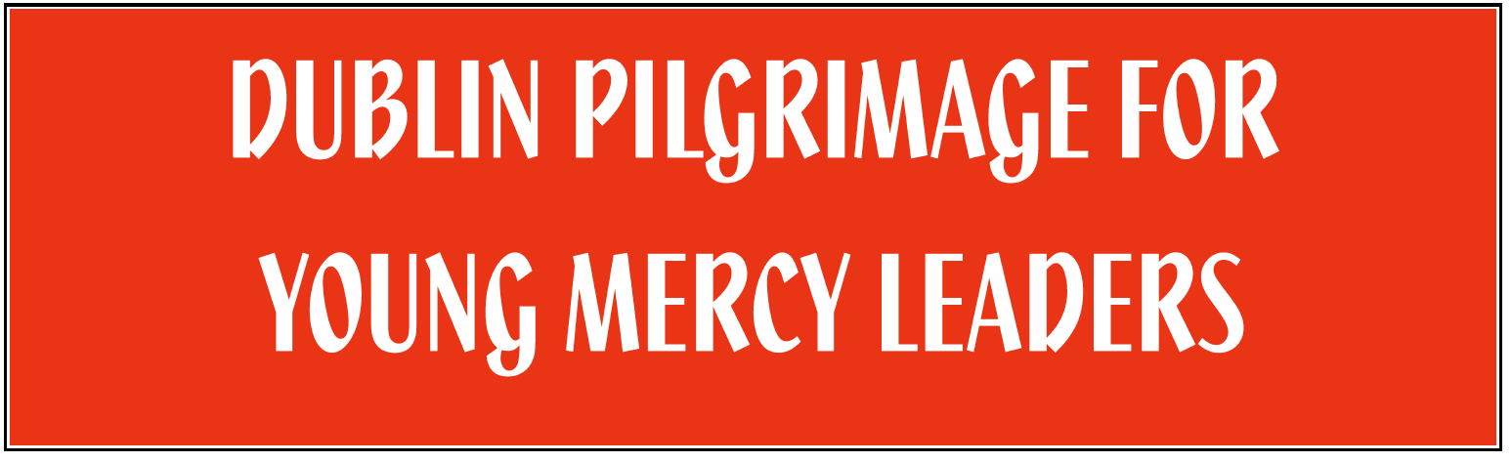

INFORMATION SHEET

Programme Content
Keynote presenters for the 2013 Pilgrimage include: Áine Barrins rsm who will break open some of Catherine McAuley's story; Karen Schneider rsm, MD, a paediatric physician with Johns Hopkins University and Health System, who will talk about global Mercy ministry and share stories of her ministry with people living in extreme poverty in various countries around the world; and Mary Reynolds rsm, Executive Director of Mercy International Association, who will engage the theme of Mercy leadership today. These keynote presentations will be combined with workshops, discussions, rituals, socials, and the sharing of gifts and talents in an evening talent show.

Programme Schedule & Meals Included
Day/Date | Beginning Time | Ending Time | Meals
Tuesday, 16 July | 3.00 p.m. | 8.00 p.m. | Light evening meal
Wednesday, 17 July | 9.00 a.m. | 8.30 p.m. | Hot midday meal;  Light evening meal
Thursday, 18 July | 9.00 a.m. | 8.30 p.m. | Hot midday meal;  Light evening meal
Friday, 19 July | 9.00 a.m. | 4.00 p.m. | Light midday meal

Location of Pilgrimage
The Pilgrimage will be held at two locations: Mercy Secondary School, Inchicore (Thomas Davis Street West, Goldenbridge, Inchicore, Dublin 8, www.mercyinchicore.ie) and Mercy International Centre (64a Lower Baggot Street, Dublin 2, www.mercyworld.ie). All plenary sessions will be held at Mercy Secondary School. You will have various workshops, midday meals, and prayer rituals at Mercy International Centre, which is the original house built by Catherine McAuley.

Accommodation
Delegations are responsible for securing their own accommodation. We recommend that a hotel or hostel in City Centre that will be accessible to both pilgrimage locations by public transportation or walking. Locations that some delegations have been exploring include: Abbey Court Hostel (http://www.abbey-court.com/), Arlington Hotel (http://arlington.ie/), Harding Hotel (http://harding.ie), and Jury’s Inn (http://www.jurysinns.com/).

Transport Each Day of the Pilgrimage
Each delegation will be responsible for arriving at the Pilgrimage location each day (three days at Mercy Secondary School and one day at MIC) and for your return from Mercy Secondary School to your hotel/hostel each night. Mercy International will provide transport between the two sites during the day. Mercy International will assist you with maps and directions from your chosen City Centre hotel/hostel to the two site locations. Mercy Secondary School is accessible to City Centre by using the Red Line of the LUAS (light rail system for Dublin), and Mercy International Centre is accessible to the City Centre by either a 20-25 minute walk or by using Dublin Bus.

Pilgrimage Attire
There is no dress code for this pilgrimage and respectable casual attire is acceptable. Summertime peak temperatures range between 18°C (65°F) and 24°C (75°F) with lows between 6 and 10°C (mid-40s–50°F). Expect rain at any time.

Talent Show and Evening Social
There will be a talent show on Wednesday evening, and a social on Thursday evening. We encourage you to prepare either a group act or an individual act for the talent show. Your delegation leader will hear more about the social during a conference call in early May, but be thinking of music, dances, or games from your country/culture that you may want to share with others.

Registration Fee
The registration fee of €250 is for each participant (student and staff/chaperone). Delegations will pay at the time of registration; check with your delegation leader for the time your payment is due. This fee covers all programme costs, mid-day and evening meals, snacks, transport between pilgrimage sites of Mercy Secondary School and Mercy International Centre. Most hotels/hostels provide breakfast, but check with your accommodation site to ensure your fee is for ‘bed and breakfast’ and not ‘room only.’

Updates on Pilgrimage through Facebook
Regular updates on this pilgrimage will be posted on our Facebook page. To follow us on Facebook, indicate that you ‘Like’ MIA Young Mercy Leaders.

Pre- or Post-Conference Touring
Several overseas delegations are arranging for extra time in Ireland or other European countries in conjunction with this pilgrimage. There is an association of tour operators here in Ireland, and a list of their member organizations can be found at: http://www.itoa-ireland.com/members-list/. Tour companies who most frequently bring groups to MIC are Abbey Tours (http://www.abbey.ie) and CIE Tours (http://www.cietours.com/). Last year, some delegations arranged for a service-learning experience of the peace and reconciliation process in the North of Ireland through Corrymeela (http://www.corrymeela.org/). Patti Donlin rsm (pdonlin@olma.org) has extended an invitation to other delegations to join two USA Mercy schools in touring popular Irish sites. Space is limited, so if interested contact her as soon as possible.

Transport to/from Airport
Few City Centre hotels and hostels provide airport shuttles, but Dublin Bus 747 or the Aircoach will bring your delegation to a location within walking distance of your hotel/hostel. The cost ranges from €6-7 one-way, and €12 for round-trip/return ticket.

Visa and Currency Issues
Most participants in this pilgrimage will not need to apply for a visa in advance of your arrival in Ireland. Mercy International Association will alert your delegation leader if you are coming from a country that does need to apply for a visa prior to arrival. If you are a citizen of a country other than the country in which your school is located, please check the visa requirements for entering Ireland (list of countries posted on Citizens Information website: http://www.citizensinformation.ie/en/moving_country/moving_to_ireland/coming_to_live_in_ireland/visa_requirements_for_entering_ireland.html).

Monetary transactions in Ireland are in Euros. If your pre- or post-conference touring includes time in the North of Ireland, the currency there is the British Sterling Pound. Most vendors accept MasterCard or Visa.

Additional Questions
If you have additional questions or concerns, feel free to contact your delegation leader or MIA staff:
Mary Kay Dobrovolny rsm (heritage@mercyinternational.ie) or Kathy Higgins rsm (facilities@mercyinternational.ie). Mary Kay and Kathy can also be reached at +353 1 661 8061 (from the Republic of Ireland: 01 661 8061).

